ENGE707 Team Low Battery Progress Report

Problem Definition and Dataset Selection

It is common within the telecommunications industry for customers of one telecommunications service to “churn” (to leave their service for another) when unsatisfied with their service or for various other reasons. This results in the loss of recurring revenue for the company but lost due to customers leaving.
Due to this, the telecommunications market is often competitive as customers can easily churn, leading to telecommunications companies having to fight for market share to survive as a business.
Thus, a problem: customers of Telecom services are switching providers/churning causing loss of recurring revenue.
We set out with the objective of seeing if we can develop an end-to-end data engineering and machine learning pipeline to predict customer churn and investigate the factors associated with customer churn.
The idea: By investigating the reasons linked with customer churn, any particular telecommunications company can focus their efforts on improving on these particular aspects to reduce customer churn, which will potentially decrease the loss of recurring revenue, improving their business economics.
Our investigation, while not being sponsored or funded, has a few stakeholders who may be interested:
- The higher ups of a particular telecommunications company, high power high interest stakeholders in adjusting company services to decrease customer churn.
- The customers of a telecommunications company, low power high interest stakeholders, they cannot directly change the service but are interested in improving it to better suits their needs.

The dataset we chose for this investigations is:
Telecom Customer Churn Dataset
https://www.kaggle.com/datasets/shilongzhuang/telecom-customer-churn-by-maven-analytics
Access date: Friday the 31st of July 2026
It’s well suited because it is publicly available via Kaggle, containing tabular, alphanumeric data. It has more than 20 and fewer than 300 features, and we have received approval from our course lecturers for this investigation.
Currently the license is unknown, having not been specified by the author.

Data Acquisition, Inspection, and Documentation

We began by loading the provided dataset into Visual Studio Code in Python with Pandas.
Observing the shape of the dataset, we can see that it provides us with 7,043 individual records of customers (including headers), as well as 38 unique features.
.info() on the dataset reveals we have a collection of three different data types, strings, 64bit integers, and 64bit floats.
Besides the dataset we were provided a data dictionary table giving definitions for each feature. While their variable names are generally self-explanatory, we may find the definition as set by the dataset author. For example, Customer ID (The unique ID used to reference a customer given by the telecommunications company), Married (marriage status of the customer, yes or no), and Tenure in Months (the time a customer has used the company’s service measured in months).
Next, we measured the number of missing values present in each feature through .sum(). The results showed that while half of our variables had no missing values, the other half has matching missing value numbers. This suggests that there is a systematic pattern behind certain variables missing the same number of values. For example, Internet Type, Online Security, Online Backup, and 6 more variables are all missing exactly 1,526 values.
This points towards a pattern, meaning when it comes to data cleansing and transformation we may not simply delete these variables on the basis of missing too many values as it will also remove the pattern which will be useful for our machine learning.
We searched for duplicate records by checking entire rows against another as well as checking customer IDs against others. Reasoning that the company could have duplicated entire records or just the record with a mismatched customer ID. Both searches came up empty.
We also inspected our various data points for what we deemed usual values for each variable, then from there we would inspect whether they were invalid values or not. We did this based on certain assumptions and had mutual agreement on the thresholds and reasoning. Here are our assumptions for each variable checked:
- A customer cannot be equal to or less than 0 years old (a newborn customer using telecommunications is extremely abnormal)
- A customer above 100 years old is odd and will be flagged, but doesn’t mean invalid, we will inspect it case by case if so
- Total revenue cannot be less or equal to $0.00, as they would not quality to the definition of a “customer”, thus wouldn’t be in this database
- Number of dependents cannot be less than 0 (illogical)
- Number of referrals cannot be less than 0 (illogical)
- A customer’s Tenure in Months should not be less than 0 (but may be equal to zero as perhaps they have only joined for a week for example, thus sitting between 0 and 1 months of tenure)
- Avg Monthly Long Distance Charges cannot be less than zero (illogical)
- Avg Monthly GB Download cannot be less than zero (illogical)
- Monthly Charge should not be less than 0 (could point towards a refund, flagging if present)
- Total Charges cannot be less than zero (wouldn’t define as a customer)
- Total Refunds cannot be less than zero (illogical, a refund value is always positive)
- Total Extra Data Charges cannot be less than zero (illogical)
- Total Long Distance Charges cannot be less than zero (illogical)
All of these checks came up with zero values meeting such criteria, except for Customers with negative monthly charge meeting 120 of them.

Data Cleansing and Transformation

It is at this point of the investigation where we noticed that certain features included may not be useful in specifically machine learning for determining reasons a customer may churn. For example,
- Customer ID, a randomized ID assigned to a customer, no pattern present nor a customer choice, but we already used it to check for duplicate records (none were found)
- City, the city the customer is living in. We mutually reasoned that it shouldn’t affect churn reasons
- Zip code, the house code of a customer, reasoned not to be relevant to churning factors as it’s hard to change and totally unique to a single customer (there won’t be 10 of our customers living at the same property)
- Latitude, same reason with the zip code
- Longitude, same reason with the zip code
- Paperless billing, we reasoned that it’s up to personal preference and unrelated to the service that the telecommunications company provides, thus irrelevant
- Payment method, same with paperless billing, a personal preference we believe is separate from churn
Additionally, there were two more variables that we decided to drop for a different reason.
- Churn Category
- Churn Reason
The majority of these variables were missing values, resulting in 5,174/7,043 (73.46%) of the population to miss values. We decided we could not reasonably use these variables.
Therefore, for the variables and their reasons above, I have dropped them from the cloned dataset I had created just before cleaning permanently. We reasoned that they are irrelevant moving forward and thus removed. This decision left us with 29 variables left.
We did this to ensure we followed the ELT data pipeline where we saved the data and cloned it before transforming it permanently. This enables us to have two tables, a raw original and a transformed clone allowing us to compare and reverse changes if need be.

Going back, we went and investigated those 114 records of customers who had a negative monthly charge as it was the one unexplained unusual value.
First, we checked over whether the negative monthly charge was caused by a refund, Total Refunds reported mostly $0.00s. We didn’t find evidence suggesting that the negative monthly charge was another instance of a refund going through.
Next, we checked the unique values and how many times they occurred in the negative monthly charges. Results are odd, numbers only range between -$1.00 to -$10.00, they’re oddly uniform and rounded showing a near flat distribution between all 10 negative values.
We then investigated whether they were subscribed onto some of the telecommunication company’s services, the result shows yes, they were. They were using Phone Service, Internet Service, and commonly showed a decent in length Tenure in Months. In other words, for that current month the customers were being paid in small exact amounts to use the company’s services.
Lastly, we investigated those customers’ Total Charges, Total Revenue, Total Refunds, and additional Total charges for extra data and long distance. We found that they were all either exactly $0.00 or positive, the customers net paid the company and were using their additional charged services but somehow for exactly that month they were gaining money from the company.
We could not come up with a logical scenario where this wasn’t an error. We had thought perhaps the company awarded them with a small amount of spending money for churning/leaving, but certain customers did not leave at all which denies the theory. We then thought that perhaps it was a special promotion but dropped the theory due to the absurd economics of such an event.
In the end we reasoned that it had to have been an error. This was only present in 114 records, present in less than 2% of our entire database, so we thought it was appropriate to completely remove those records reasoning they were errors.

Having finished up our only unusual value analysis we moved onto cleaning and encoding the rest of our data table in preparation for analysis.
For certain features it was easy to hot encode two option strings into 0s and 1s to represent them. Afterall, the machine learns on numericals, not strings. Certain features like Gender, Married, Internet Service, and so on were mapped with No = 0 and Yes = 1.
‘Offer’ was a bit different. It represented the last marketing offer the customer accepted ranging from “None” and “Offer A” to “Offer E”. To encode this properly I reasoned that the None offer was fundamentally different from the different offers, None gave no additional benefits meaning any offer between A to E provided a benefit to the customer. However, the details behind each of the offers are unknown, so they should have the same rankings as simply different choices. In other words, all of the offers from A to E are to be hot encoded as the same ranking, but all of them are ranked higher than None. This ensures we preserve the specifics behind offers without fully deleting None. To do this, I had made a column specifically for None where None = 0 and any of the other offers from A to E = 1. Then I made each of the A to E offers their own column, setting them = 1 if they received the corresponding offer and = 0 if they did not receive the corresponding offer. This should enable the machine to learn that None was ranked lower than all the others but still be able to differentiate A to E as different choices of yes, they received an offer.
Next was Internet Type. We thought it was appropriate to treat the different internet types simply as hot encoded values rather than have a ranking since they each have their pros and cons, but no internet was the least ranked as it meant having no internet at all as compared to different types of internet. To do this we used the same approach as Offer.
For Contract (Tenure as signed by Contract, NOT actual Tenure in Months) we decided to hot encode them despite the nature of the values being rather numerical if transformed. This is because there were only three unique values: Month-to-Month, One Year, and Two Year. If we formed a ranking it would suggest the difference between one year and two years is the same size in difference compared to month-to-month vs one year. Thus, unique columns for each were made.
Customer Status was simple, three unique values: Stayed, Churned, or Joined. Joined strays from our original question, thus it would be appropriate to ignore them as we aren’t considering those who joined but rather those who are currently or left. Then we hot encoded Stayed = 0 and Churned = 1 (different choices, no apparent ranking).
Avg Monthly Long Distance Charges was simple, by the data dictionary’s definition missing values are equal to = 0, so I simply filled the missing values as 0, and it left us a hot encoded 0 or 1. Avg Monthly GB Download also had that definition; thus, I also replaced all missing values with 0 and left it.
The rest of them: Online Security, Online Backup, Device Protection Plan, Premium Tech Support, Streaming TV, Streaming Movies, Streaming Music, Unlimited Data only show = 1 is service is present and = 0 if they do not have the service. The thing is that an earlier feature like Internet Service if = 0 will systematically cause these to have missing values as they technically are NA values but can also be interpreted as No. Therefore, I filled missing spots with 0s and interpretation is preserved. Put another way, the customer can’t have Online Backup if they never had internet, but really they still don’t have Online Backup, so no they don’t.
Next, we began a look for statistical outliers as defined by IQR box and whiskers for all numerical features with a meaningful continuous range.
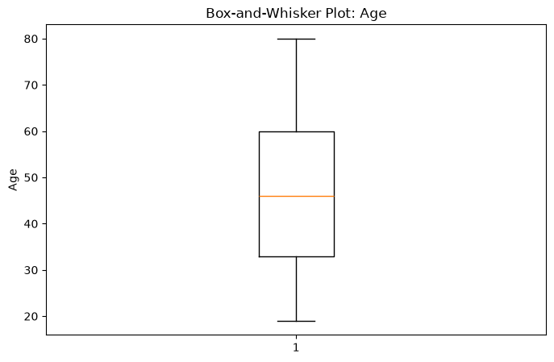
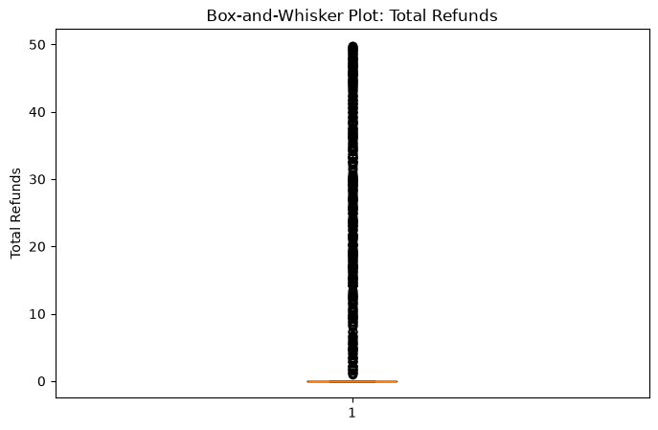
Some plots were good, but others were mostly statistical outliers.
Through a threshold calculation test we found for certain plots like Total Refunds it was considering a huge number of records as outliers simply because the majority of all customer records were distributed as a single value (most of them never refunded anything), therefore forcing all other points as outliers. We took no action because this is expected behaviour.
Total Revenue had 7 really high outliers, investigation shows they were long time patrons of 6 years, so no action expected behaviour.
Some customers had a high number of dependents, distribution shows that 4954 customers has 0 dependents, forcing anything above 3 to be an outlier. No action taken expected behaviour.
Number of referrals has one customer with 11 referrals; the rest are mostly flatly distributed. Upon investigation this person had very normal features, nothing abnormal, no action taken.
Total Long Distance Charges showed 129 with high total charges, we found they were simply paying a lot per month as well as stayed a long time, thus pushing up the total per lifetime.
For the rest of the outliers, IQR check provided the max and such values. They weren’t extreme nor we were aware of a cap. We assume these to be high but normal, no action taken.

Exploratory Data Analysis and Visualisation

A distribution plot was created to show overall balance of customers who stayed vs churned. Providing context for further analysis and identifies imbalances.
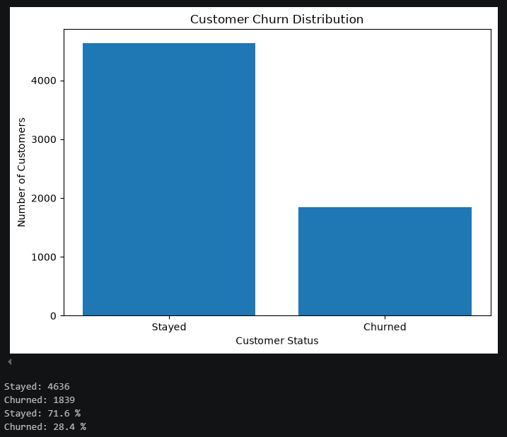
We found a clear moderate class imbalance, further interpretation and analysis should be taken cautiously as a majority population has more influence over patterns.

Next, we produced a correlation heatmap for our features to get a basic understanding as well as a visual for the patterns present between which features are generally correlated both positively and negatively against one another.
It MUST be noted that correlation does NOT equal causation. The correlation heatmap does not provide enough evidence to reasonably prove that one feature causes a positive or negative presence in another feature.
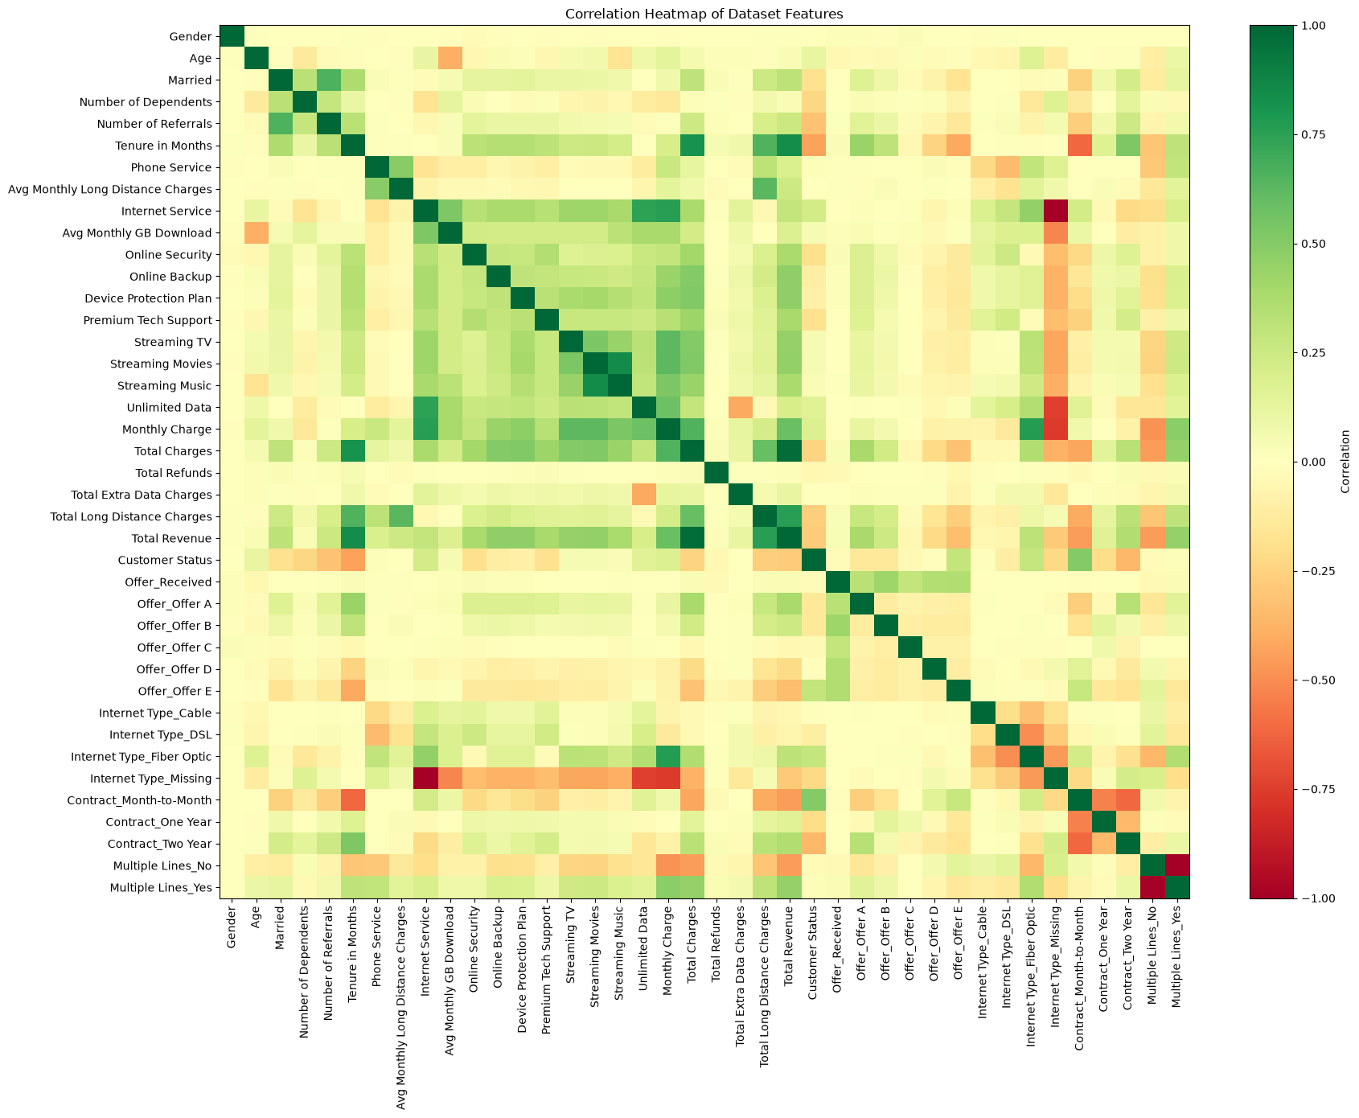
A few features are noteworthy.
We can observe a strong positive correlation between Tenure in Months to both Total Charges and Total Revenue. This is to be expected through reason, as the longer a customer stays with the telecommunications company paying for their services, the higher total charges and total revenue they can expect to pay simply because of economics. Put simply, the longer a customer uses a paid service, the more they will pay in total as time goes on.
Next, Streaming Movies and Streaming Music seems to display a strong positive correlation. This is also reasonably expected, as movies and music are strongly linked in entertainment media, we can expect a demographic that enjoys one to enjoy another. Thus, the strong positive correlation.
One thing to note, the correlations between certain features are to be expected to have such a strong negative correlation purely by the nature of the way we encoded certain features when cleaning the data to preserve their systematic pattern of missing values. Examples such as Internet Service being strongly negatively correlated to Internet Type_Missing.

Following these correlations, we will conduct a pair plot using these relationships to analyse factors for churn. These currently show the most promise.
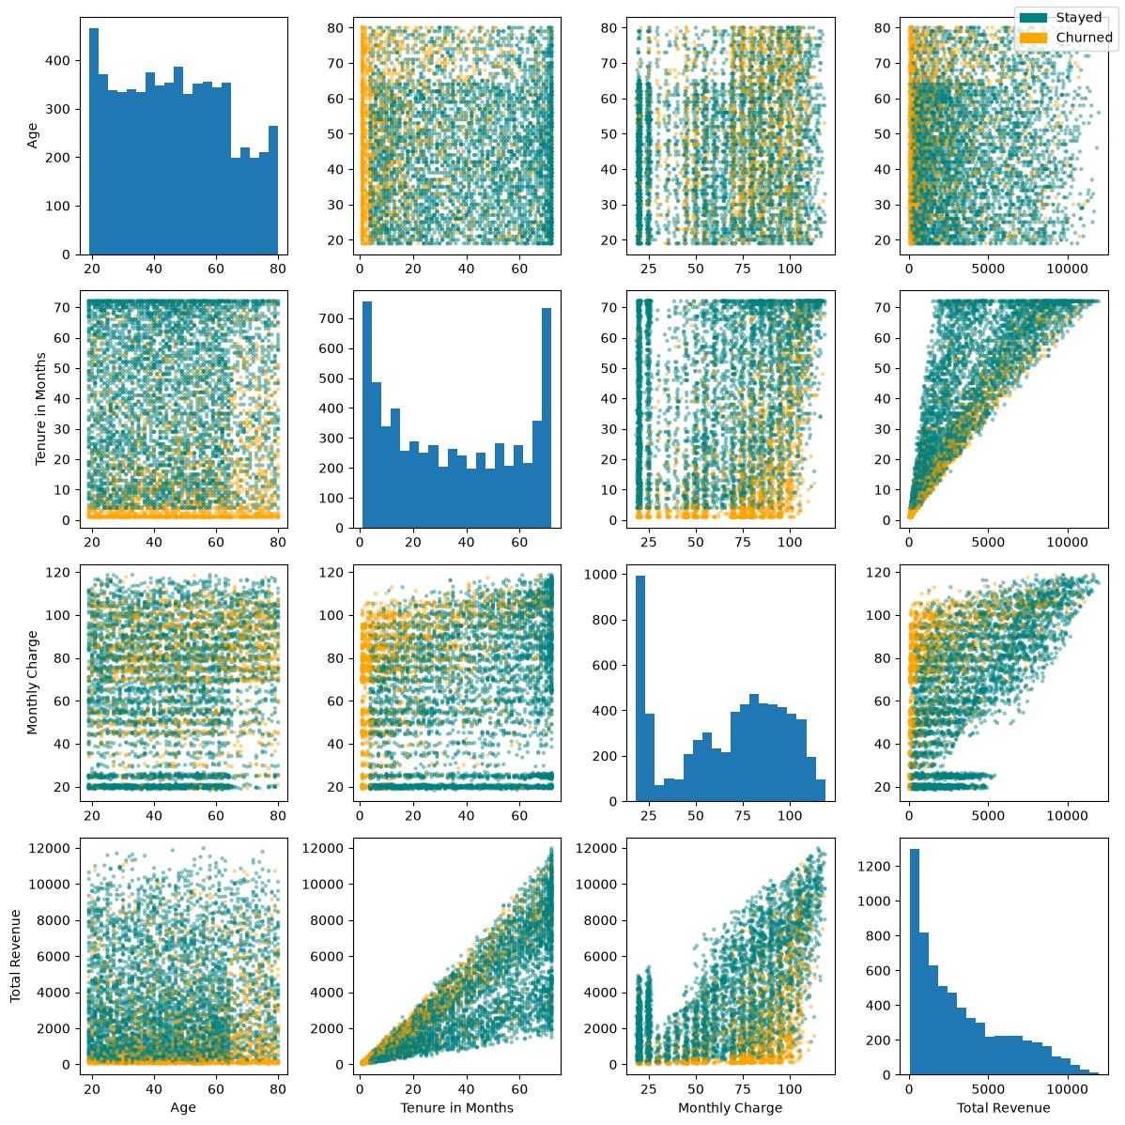
Tenure in Months vs Monthly Charge, and Tenure in Months vs Total Revenue are particularly significant with the same overall message.
We notice a clear trend in these:
Customers who pay a lot per month and in total over their lifetime service with the company appear substantially more likely to churn as monthly tenure increases.

Next, we used boxplots to compare the distributions of numerical variables between churn and stay. We will use this to identify median, spread, and unusual values.
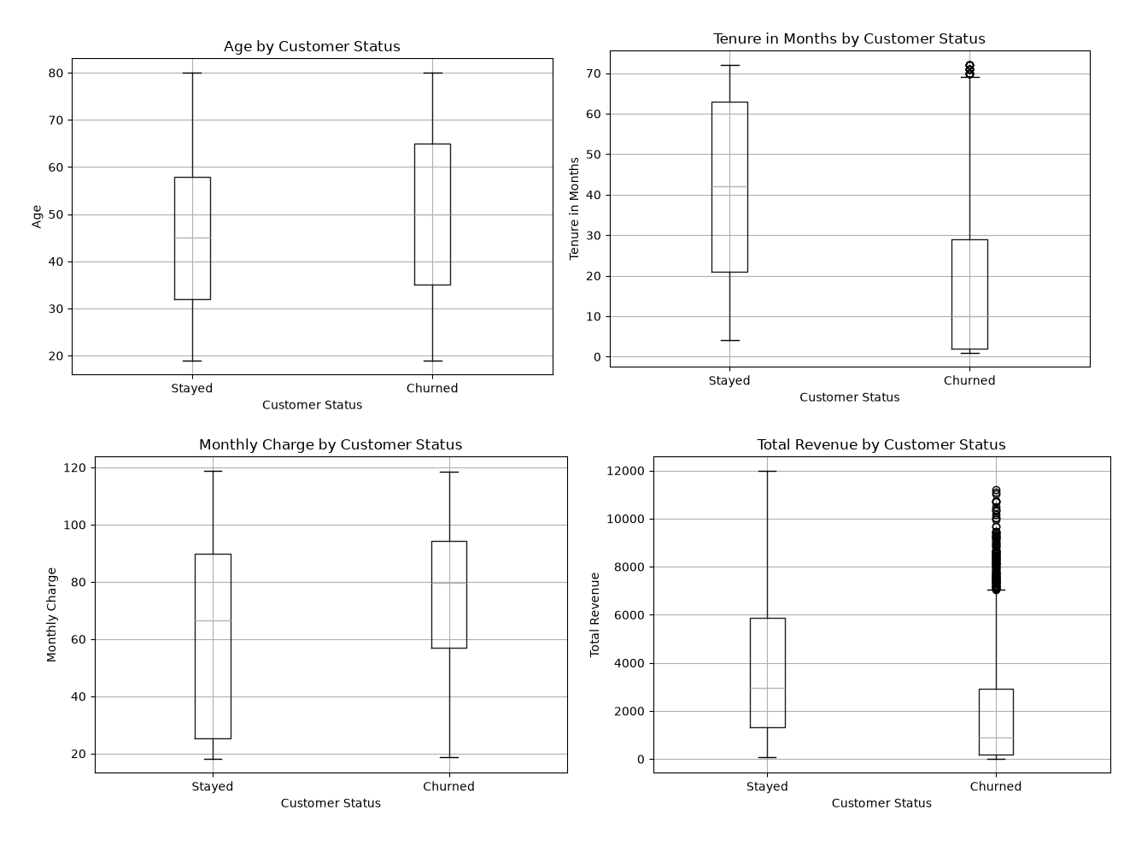
A low tenure is the strongest churn signal, but the company cannot adjust that, so I’ll leave it.
Secondly, higher monthly charges are associated with churn. This may indicate that a high price contributes to churn.

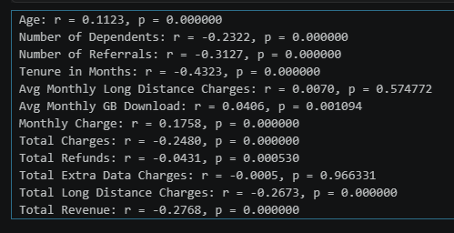
A correlation test was conducted at α = 0.05.
Results showed many variables have statistically significant correlations with churn, but many had very weak correlation coefficients.
Out of these, Tenure showed the strongest observed relationship with churn (r = -0.4323).
The null hypothesis states that there is no statistically significant correlation between every numerical feature and customer churn.
Tenure, showing the strongest correlation with churn with r = -0.4323, p < 0.001 allows the null hypothesis to be rejected for this variable.
These results indicates associations rather than causation.

Conclusion

Overall, the dataset was found to be quite consistent and complete for varied analysis. We have found several useful and meaningful patterns that indicates certain factors influence customer churn. We can continue with more advanced analysis and machine learning with this.

